Bahria University,
Karachi Campus


LAB EXPERIMENT NO.
04
LIST OF TASKS
TASK NO | OBJECTIVE
1 | Which of the following values can be assigned to variables of type float, double and decimal:
2 | Create a simple calculator which will perform all arithmetical, Bit wise operation and logical operation on two number
3 | Create a simple program to calculate Hypotenuse using Pythagoras theorem c^2 =(a^2 + b^2)

Submitted On:
____________
(Date: DD/MM/YY)
Example:1
Solution:
int squarePerimeter = 17;
double squareSide = squarePerimeter / 4.0;
double squareArea = squareSide*squareSide;
Console.WriteLine(squareSide);
Console.WriteLine(squareArea);
Output:
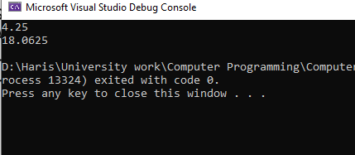
Example:2
Solution:
int a = 5, b = 4;
Console.WriteLine("Tha value of a+b is\t:{0}",a + b);
Console.WriteLine("Tha value of a+(b++) is\t:{0}",a + (b++));
Console.WriteLine("Tha value of a+b is\t:{0}",a + b);
Console.WriteLine("Tha value of a+(++b) is\t:{0}",a + (++b));
Console.WriteLine("Tha value of a+b is\t:{0}",a + b);
Console.WriteLine("Tha value of 14/a is\t:{0}",14/a);
Console.WriteLine("Tha value of 14%a is\t:{0}",14%a);
Output:
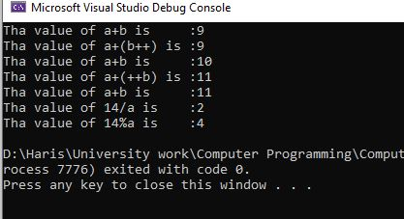

Example:3
Solution:
int one = 1;
int zero = 0;
Console.WriteLine(one/zero);
Output:
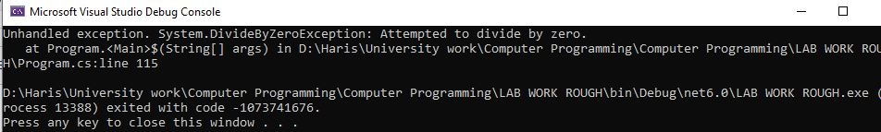
Example:4
Solution:
double dMinusOne = -1.0;
double dpositiveone = 1.0;
double dZero = 0.0;
Console.WriteLine(dMinusOne/dZero);
Console.WriteLine(dpositiveone/dZero);
Output:
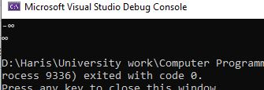
Example:5
Solution:
bool a = true, b = false;
Console.WriteLine(a&&b);
Console.WriteLine(a||b);
Console.WriteLine(!b);
Console.WriteLine(b||true);
Console.WriteLine((5>7)^(a==b));
Output:
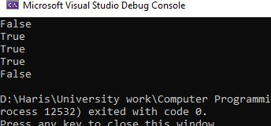
Example:6
Solution:
int x = 10, y = 5;
Console.WriteLine("x>y:\t" + (x>y));
Console.WriteLine("x<y:\t" + (x<y));
Console.WriteLine("x>=y:\t" + (x>=y));
Console.WriteLine("x<=y:\t" + (x<=y));
Console.WriteLine("x==y:\t" + (x==y));
Console.WriteLine("x!=y:\t" + (x!=y));
Output:
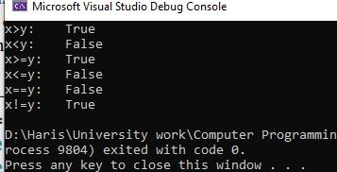
TASKS
Task No. 1: Which of the following values can be assigned to variables of type float, double and decimal:
5, -5.01, 34.567839023, 12.345, 8923.1234857, 3456.091124875956542151256683467?
Solution:
- 5 = float
- -5.01 = float
- 34.567839023 = double
- 12.345 = float
- 8923.1234857 = double
- 3456.091124875956542151256683467 = decimal
Task No. 2: Create a simple calculator which will perform all arithmetical, Bit wise operation and logical operation on two number
Solution:

int num1 = 123, num2 = 456;

Console.WriteLine("\tArithmatical Operators\n");
Console.WriteLine("1) Addition");
Console.WriteLine("Addition of {0} and {1} is {2}", num1, num2, num1 + num2);

Console.WriteLine("2) Subtraction");
Console.WriteLine("Subtraction of {0} and {1} is {2}", num1, num2, num2 - num1);

Console.WriteLine("3) Multiply");
Console.WriteLine("Multiple of {0} and {1} is {2}", num1, num2, num1 * num2);

Console.WriteLine("4) Divide");
Console.WriteLine("Divide of {0} and {1} is {2}", num1, num2, num2 / num1);

Console.WriteLine("5) Modulo");
Console.WriteLine("Modulo of {0} and {1} is {2}", num1, num2, num2 % num1);

Console.WriteLine("\tBit Wise Operators");

Console.WriteLine("1) And Operator");
Console.WriteLine("Bit Wise AND Operator of {0} and {1} is {2}", num1, num2, num1 & num2);
Console.WriteLine("2) OR Operator");
Console.WriteLine("Bit Wise OR Operator of {0} and {1} is {2}", num1, num2, num1 | num2);
Console.WriteLine("3) XOR Operator");
Console.WriteLine("Bit Wise XOR Operator of {0} and {1} is {2}", num1, num2, num1 ^ num2);

Console.WriteLine("\tLogical Operator");
bool output;
//Or operator
output = (num1 == num2) || (num1 > 120);
Console.WriteLine(output);
output = (num1 == num2) && (num1 > 120);
Console.WriteLine(output);
Output:
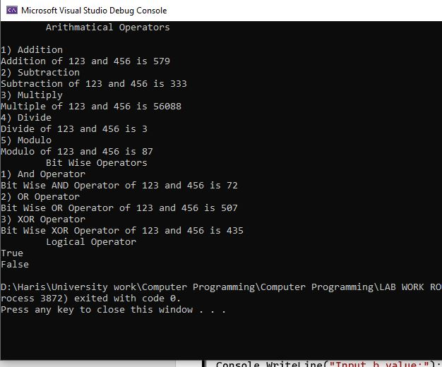

Task No. 3: Create a simple program to calculate Hypotenuse using Pythagoras theorem c^2 =(a^2 + b^2)

Solution:

double a, b, c, C_square;
Console.WriteLine("Input a value:");
a=Convert.ToDouble(Console.ReadLine());
Console.WriteLine("Input b value:");
b=Convert.ToDouble(Console.ReadLine());
C_square=Math.Pow(a,2)+Math.Pow(b,2);
c=Math.Sqrt(C_square);
Console.WriteLine("C square value is {0:0.00}",C_square);
Console.WriteLine("c value is {0:0.00}",c);
Output:
